LINUX SHELL SCRIPTING
/*BASICS*/
1. Write a script that declares two variables, adds them together, and prints the result. Explain how variable assignment works in Bash.

PROGRAM:

#!/bin/bash

a=10
b=20

sum=$((a+b))

echo "The sum is $sum"

OUTPUT:
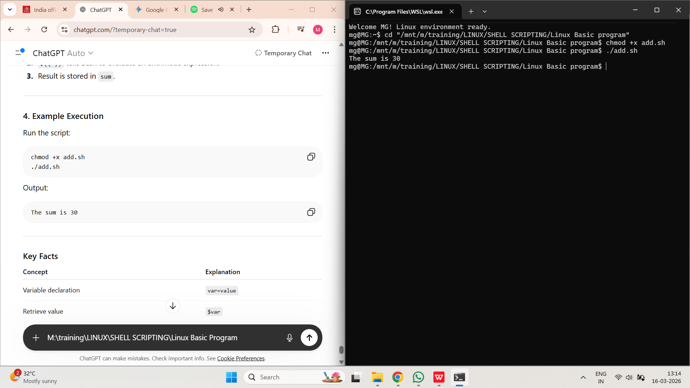

- WAP to find the perimeter of a rectangle if length and breadth are given.

PROGRAM:

#!/bin/bash

length=$1
breadth=$2

perimeter=$((2*(length+breadth)))

echo "Perimeter of rectangle is $perimeter"
OUTPUT:

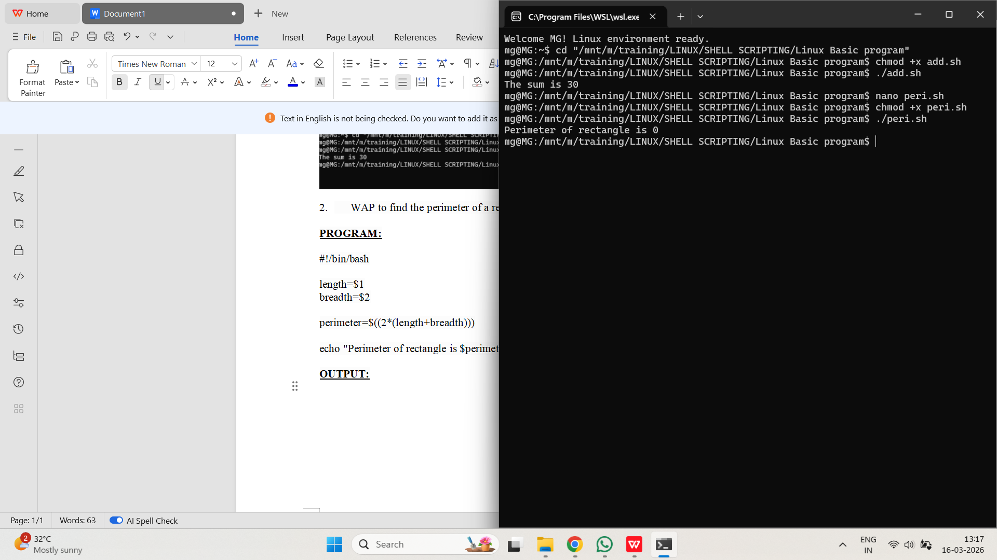

/*IF*/
- WAP to check whether the product of two given numbers is odd or even
PROGRAM:
#!/bin/bash

echo "Enter first number:"
read a

echo "Enter second number:"
read b

product=$((a*b))

if [ $((product % 2)) -eq 0 ]
then
echo "Product is Even"
else
echo "Product is Odd"
Fi

OUTPUT:
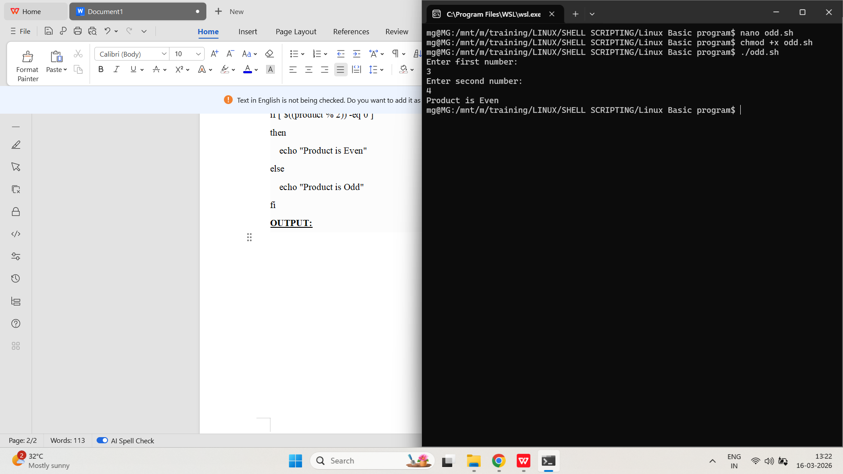

- WAP to find the perimeter of a rectangle if length and breadth are given.

PROGRAM:

#!/bin/bash

echo "Enter length:"
read length

echo "Enter breadth:"
read breadth

perimeter=$((2*(length+breadth)))

echo "Perimeter of rectangle is $perimeter"

OUTPUT:

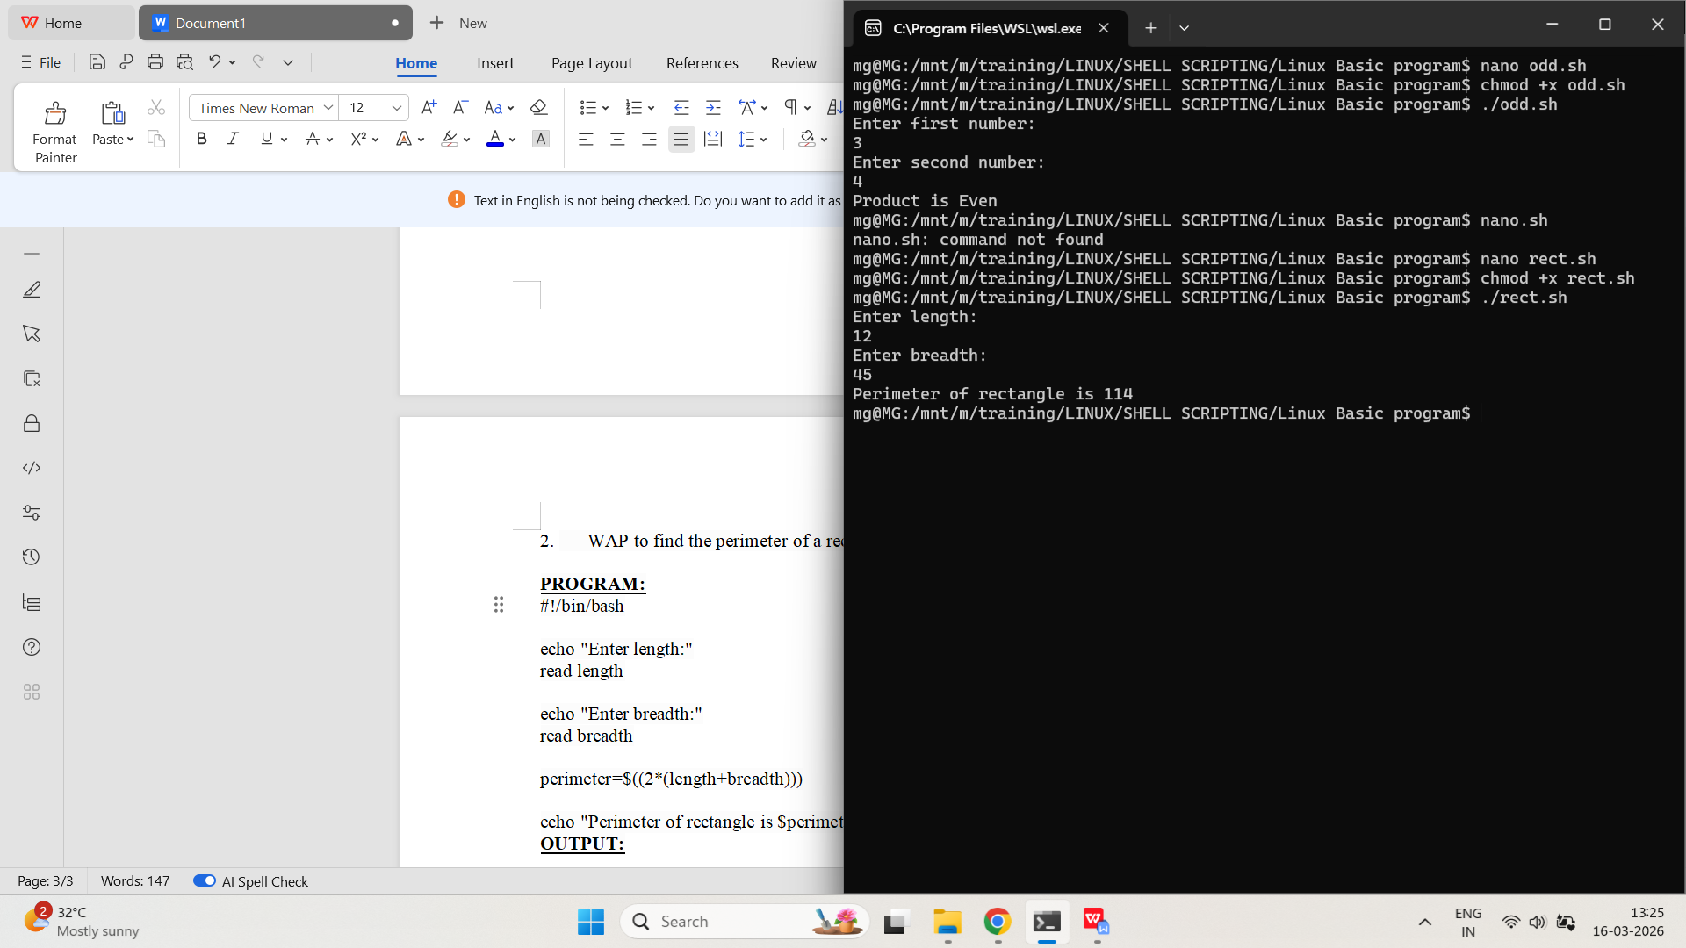

- WAP, given three sides of a triangle, to check whether the triangle is perfect right triangle.
PROGRAM:
#!/bin/bash

echo "Enter three sides:"
read a b c

if [ $((a*a + b*b)) -eq $((c*c)) ] || \
[ $((a*a + c*c)) -eq $((b*b)) ] || \
[ $((b*b + c*c)) -eq $((a*a)) ]
then
echo "It is a Right Triangle"
else
echo "It is NOT a Right Triangle"
Fi
OUTPUT:
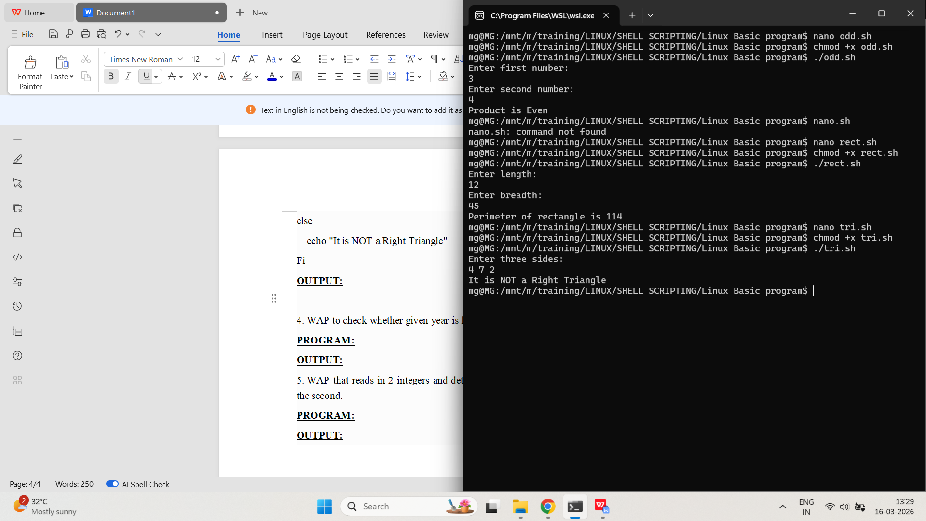

- WAP to check whether given year is leap year or not.
PROGRAM:
#!/bin/bash

echo "Enter a year:"
read year

if [ $((year % 400)) -eq 0 ] || { [ $((year % 4)) -eq 0 ] && [ $((year % 100)) -ne 0 ]; }
then
echo "Leap Year"
else
echo "Not a Leap Year"
fi
OUTPUT:
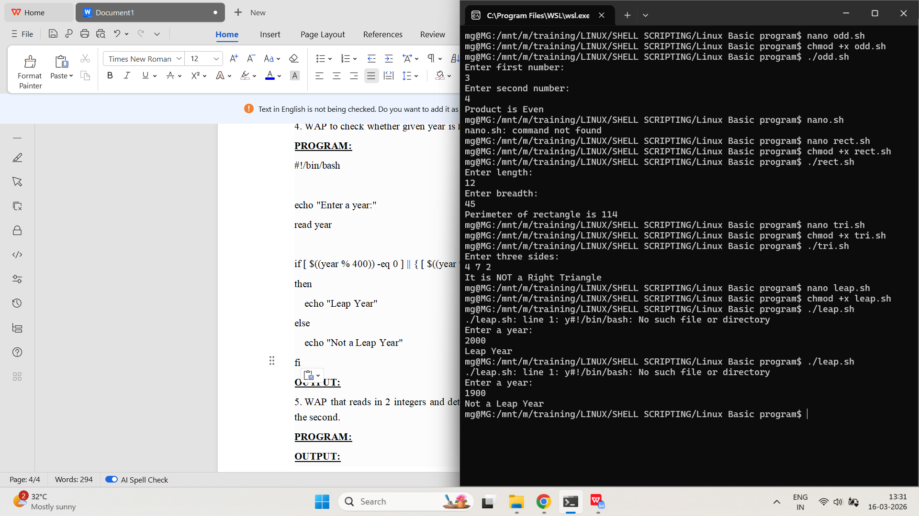
- WAP that reads in 2 integers and determines and prints if the first is a multiple of the second.
PROGRAM:
#!/bin/bash

echo "Enter first integer:"
read a

echo "Enter second integer:"
read b

if [ $((a % b)) -eq 0 ]
then
echo "$a is a multiple of $b"
else
echo "$a is NOT a multiple of $b"
fi
OUTPUT:

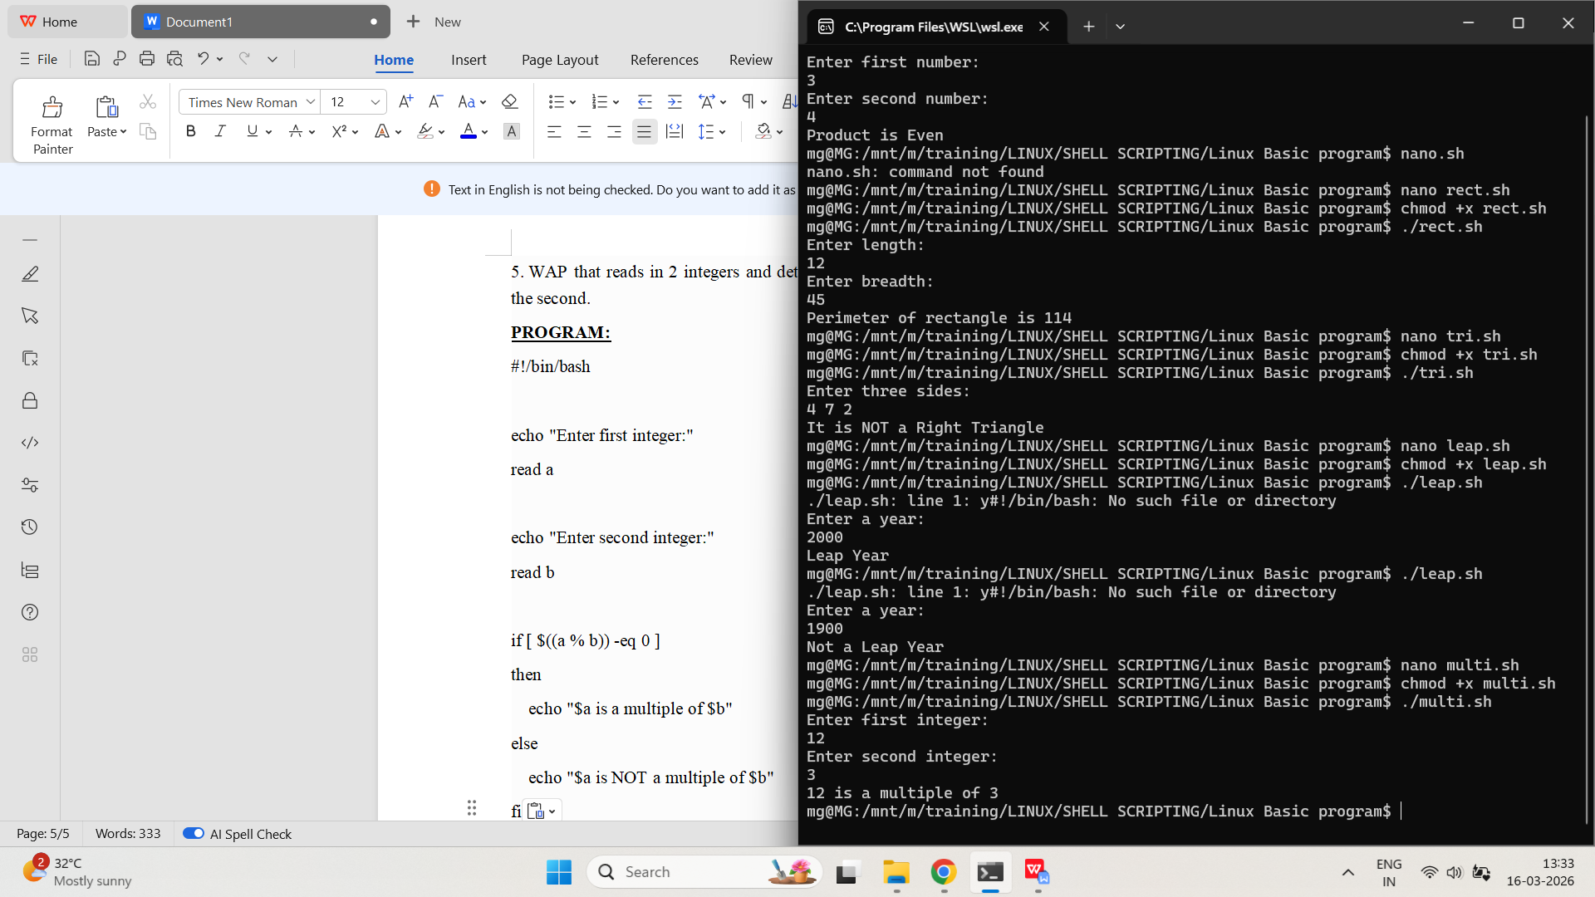

/*FOR, WHILE */
- WAP to find the smallest and largest of entered n numbers.
PROGRAM:
#!/bin/bash

echo "Enter how many numbers:"
read n

echo "Enter number:"
read num
small=$num
large=$num

for ((i=2;i<=n;i++))
do
echo "Enter number:"
read num

if [ $num -lt $small ]
then
small=$num
fi

if [ $num -gt $large ]
then
large=$num
fi
done

echo "Smallest number = $small"
echo "Largest number = $large"

OUTPUT:
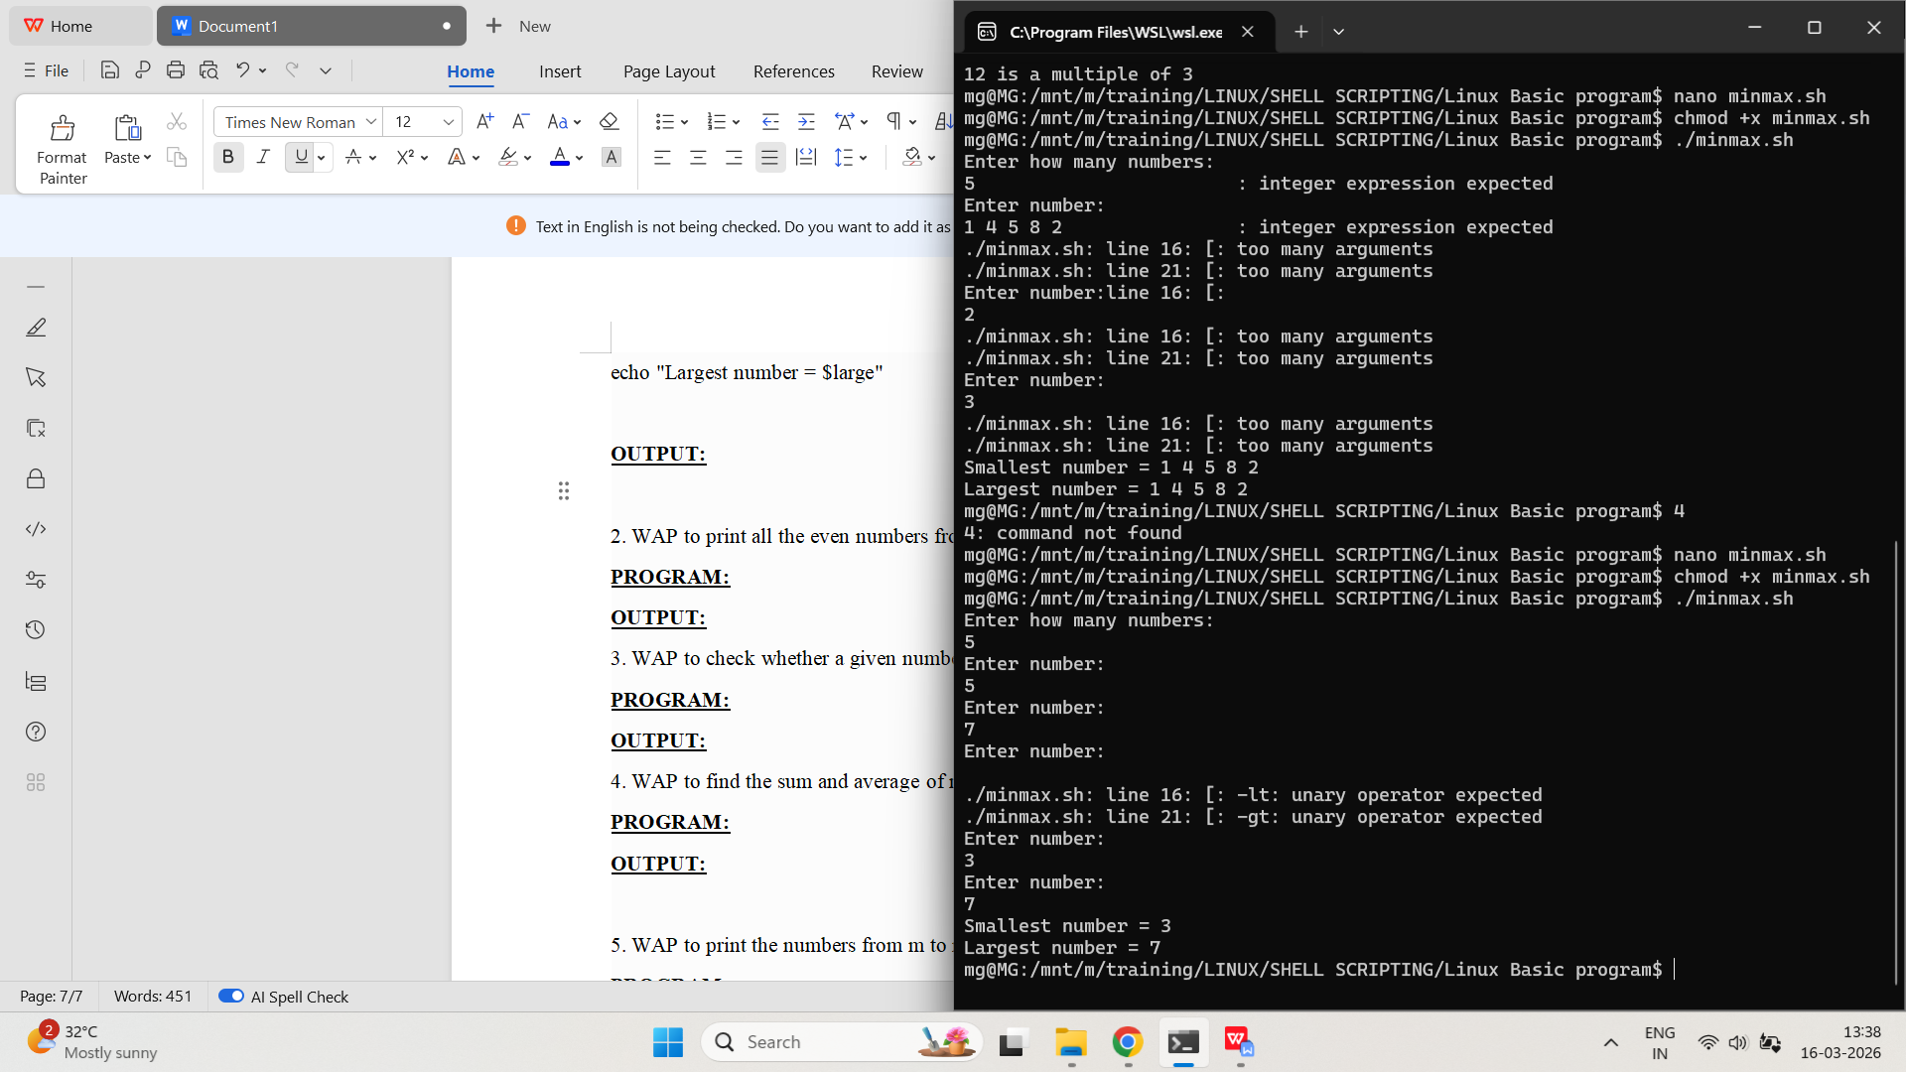

- WAP to print all the even numbers from 1 to 100.
PROGRAM:

#!/bin/bash

for ((i=1;i<=100;i++))
do
if [ $((i%2)) -eq 0 ]
then
echo $i
fi
done

OUTPUT:
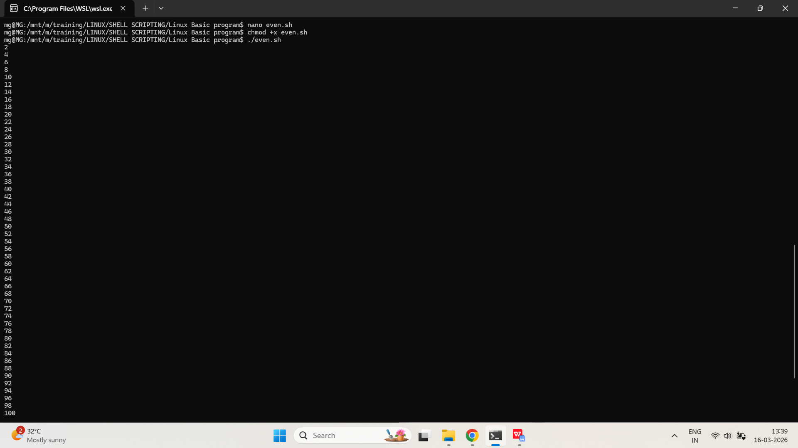

- WAP to check whether a given number is prime or not.
PROGRAM:
#!/bin/bash

echo "Enter a number:"
read n

flag=0

for ((i=2;i<n;i++))
do
if [ $((n%i)) -eq 0 ]
then
flag=1
break
fi
done

if [ $flag -eq 0 ]
then
echo "Prime number"
else
echo "Not a prime number"
fi
OUTPUT:
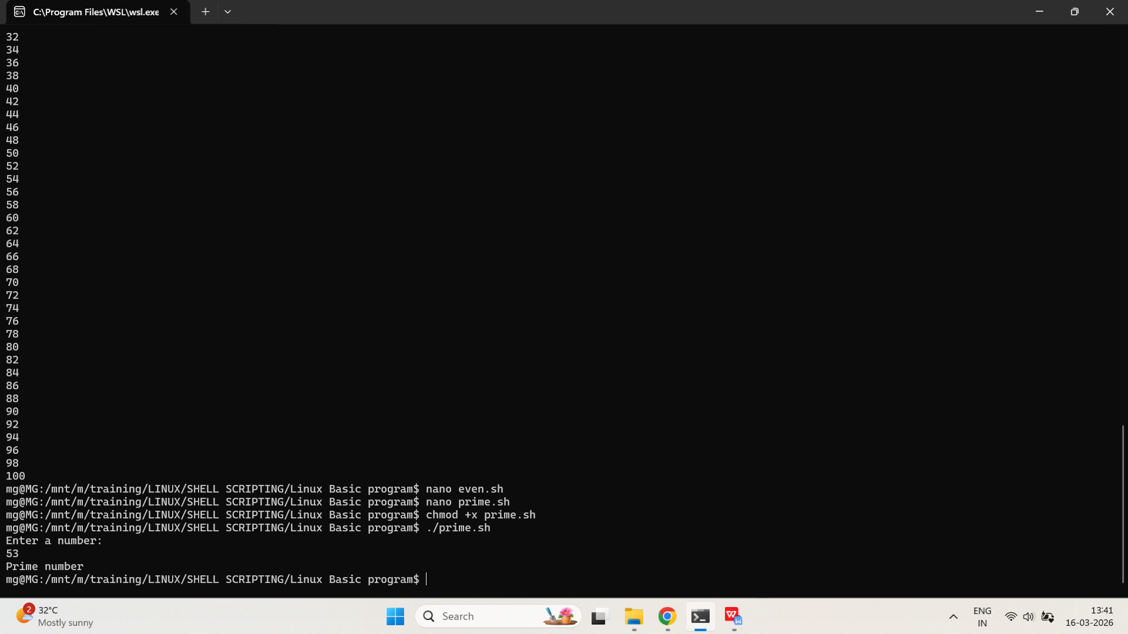
- WAP to find the sum and average of n numbers entered.
PROGRAM:
#!/bin/bash

echo "Enter number of values:"
read n

sum=0

for ((i=1;i<=n;i++))
do
echo "Enter number:"
read num
sum=$((sum+num))
done

avg=$((sum/n))

echo "Sum = $sum"
echo "Average = $avg"

OUTPUT:
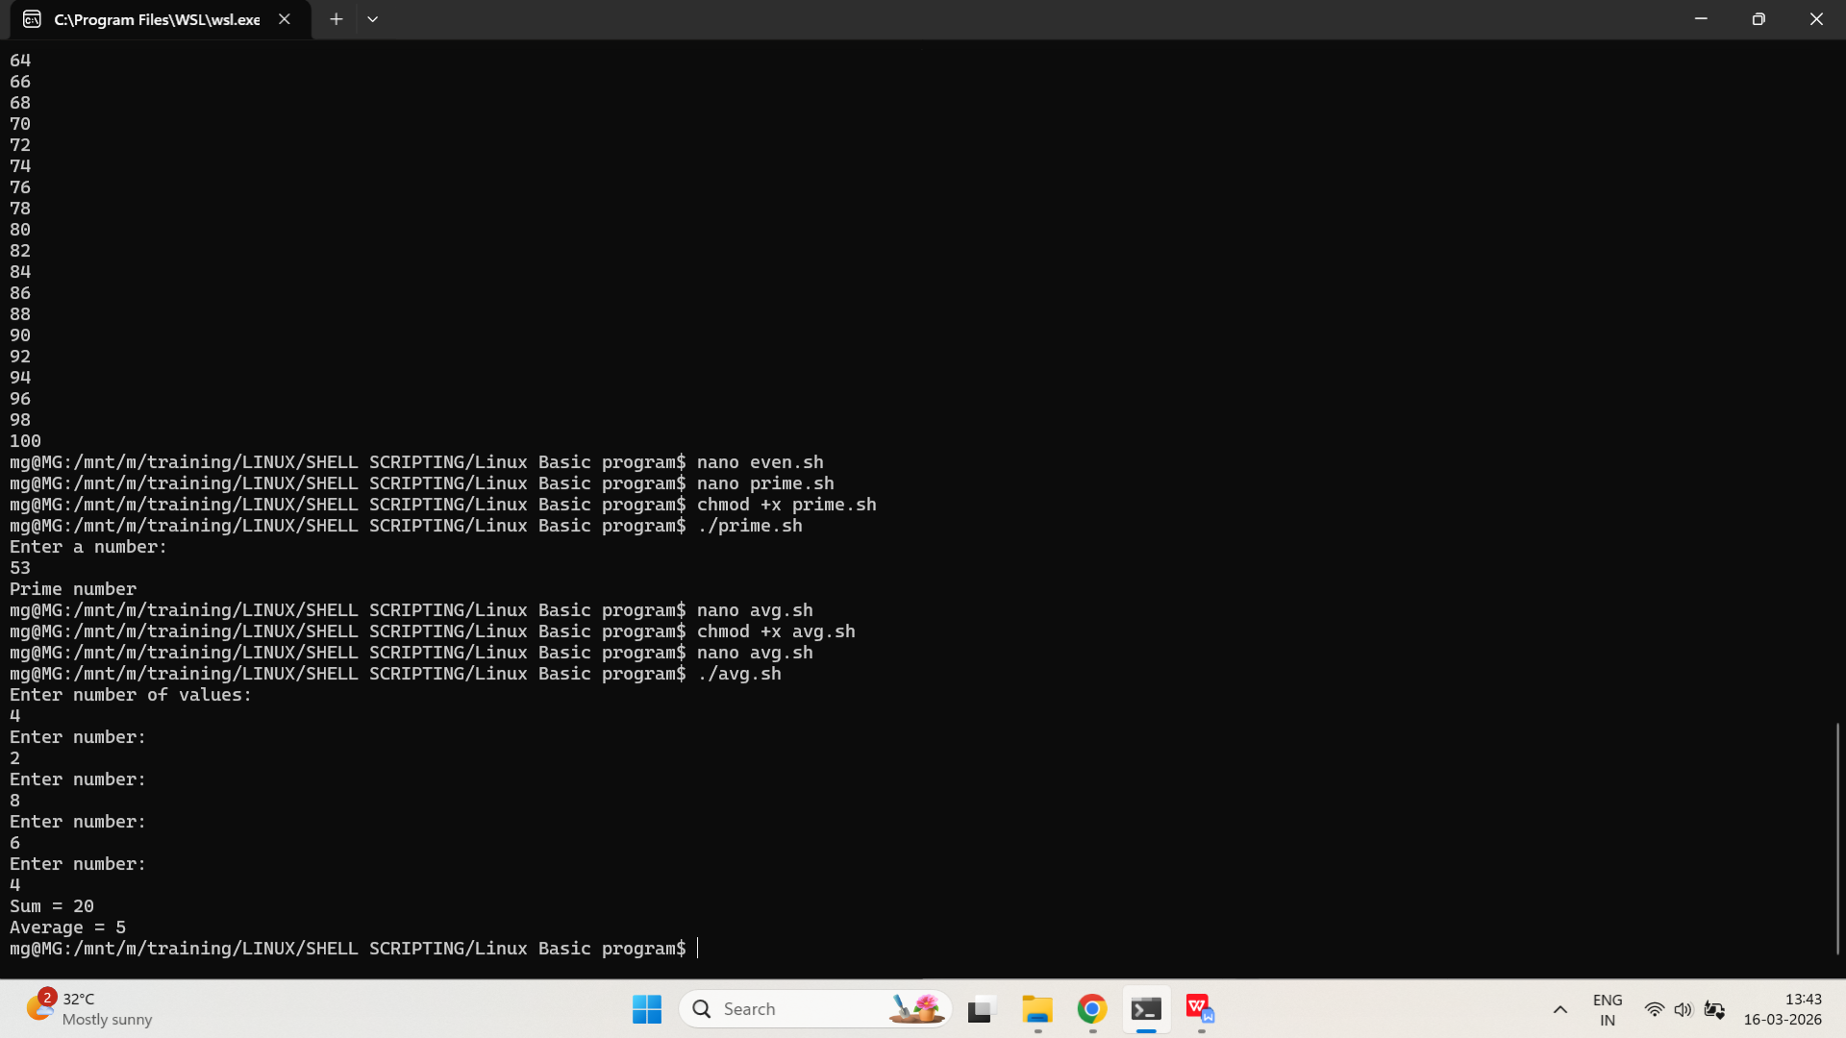

- WAP to print the numbers from m to n.
PROGRAM:
#!/bin/bash

echo "Enter starting number (m):"
read m

echo "Enter ending number (n):"
read n

for ((i=m;i<=n;i++))
do
echo $i
done

OUTPUT:
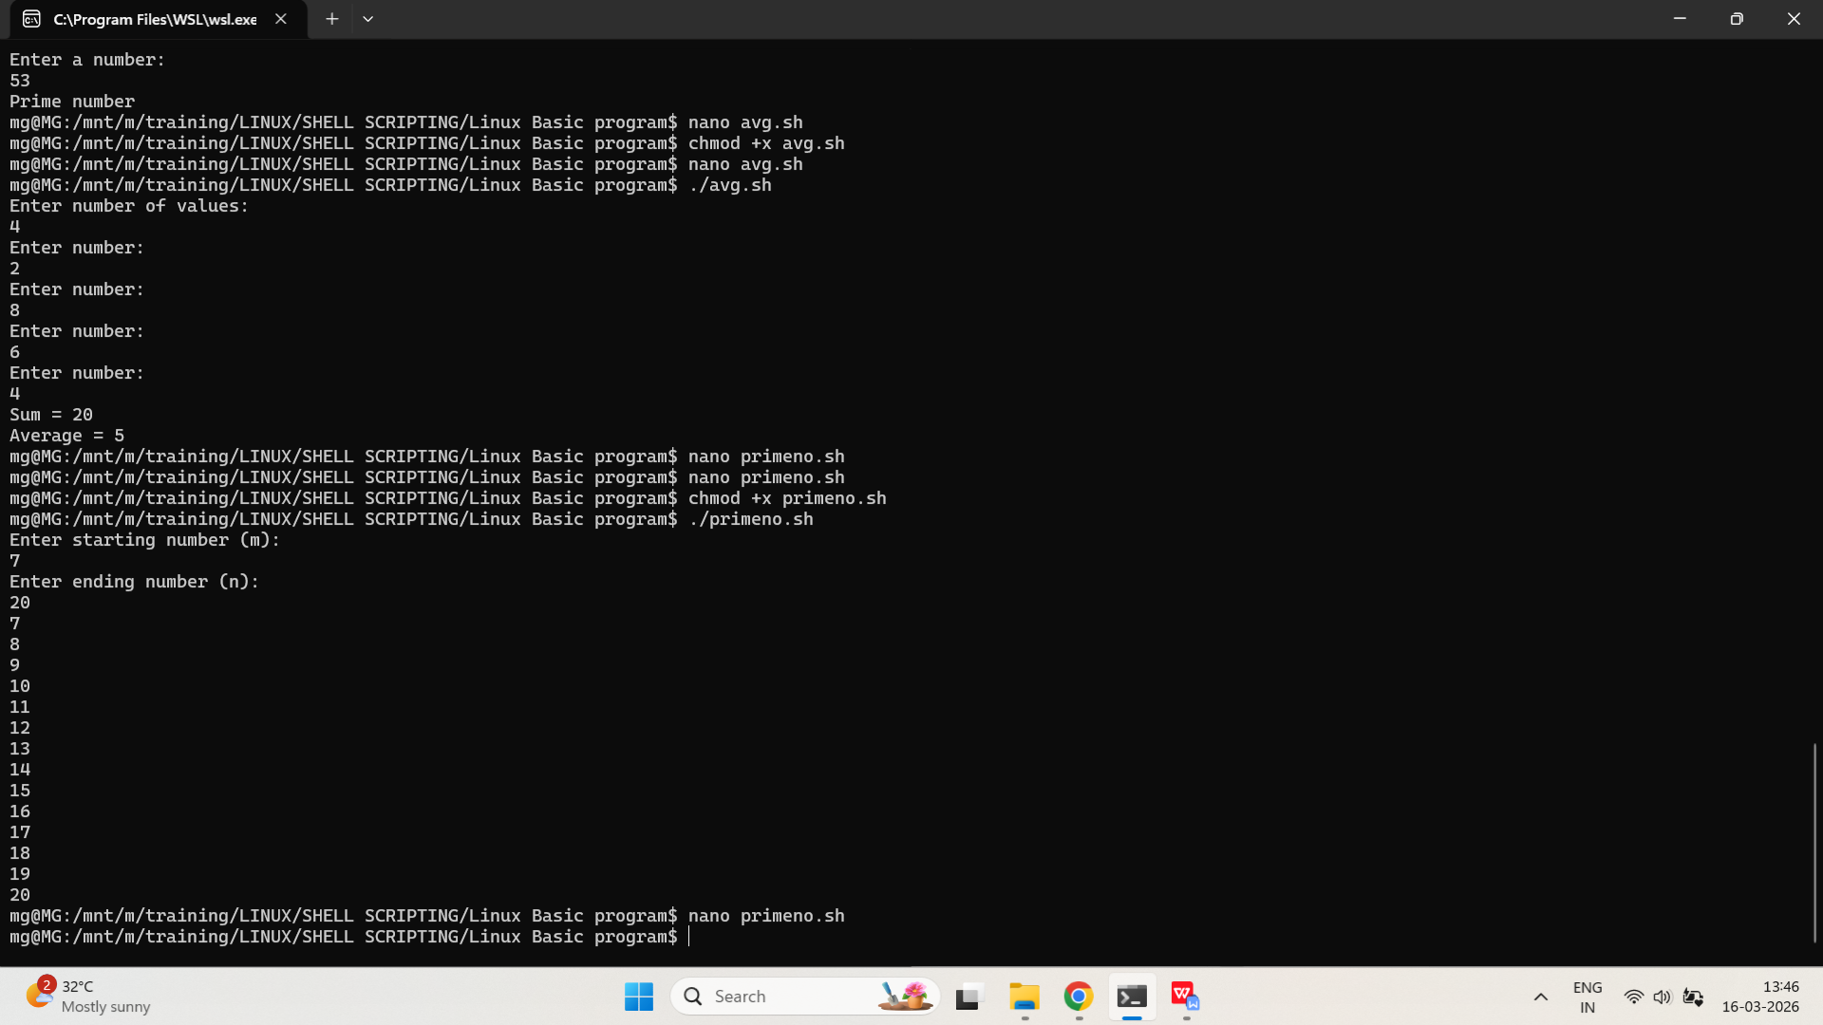

/*CASE STATEMENT*/
- Write a simple script using case that prints the day of the week based on user input (e.g., 1 = Monday, 2 = Tuesday, etc.).
PROGRAM:
#!/bin/bash

echo "Enter a number (1-7):"
read day

case $day in
1) echo "Monday" ;;
2) echo "Tuesday" ;;
3) echo "Wednesday" ;;
4) echo "Thursday" ;;
5) echo "Friday" ;;
6) echo "Saturday" ;;
7) echo "Sunday" ;;
*) echo "Invalid input" ;;
esac
OUTPUT:
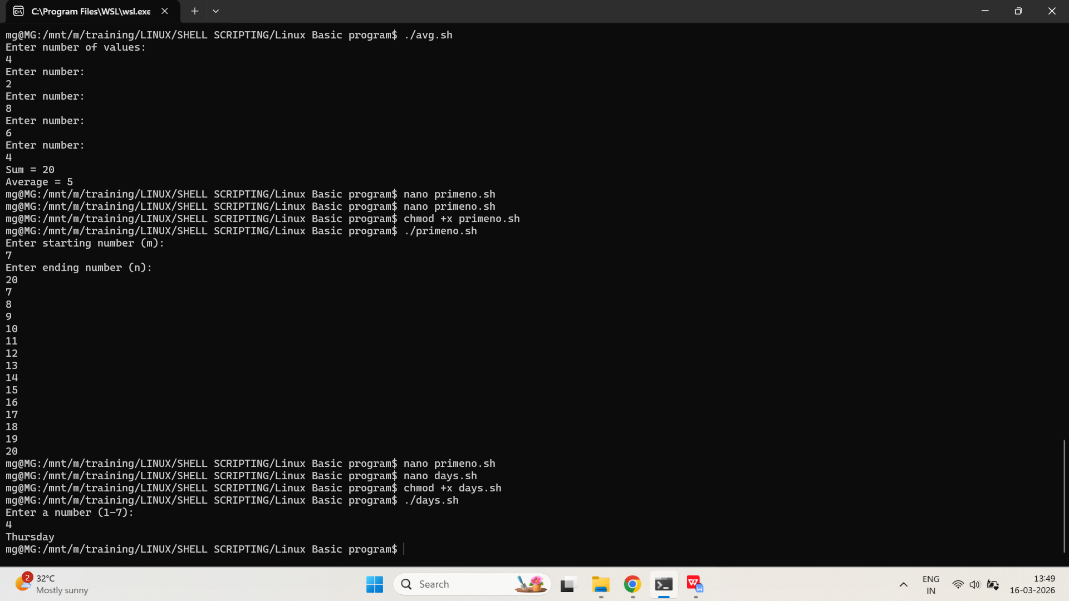

- Write a script that takes two numbers and an operator (+, -, *, /) as input. Use a case statement to perform the corresponding arithmetic operation.
PROGRAM:
#!/bin/bash

echo "Enter first number:"
read a

echo "Enter second number:"
read b

echo "Enter operator (+ - * /):"
read op

case $op in
+) result=$((a+b))
echo "Result = $result" ;;

-) result=$((a-b))
echo "Result = $result" ;;

\*) result=$((a*b))
echo "Result = $result" ;;

/) result=$((a/b))
echo "Result = $result" ;;

*) echo "Invalid operator" ;;
esac
OUTPUT:
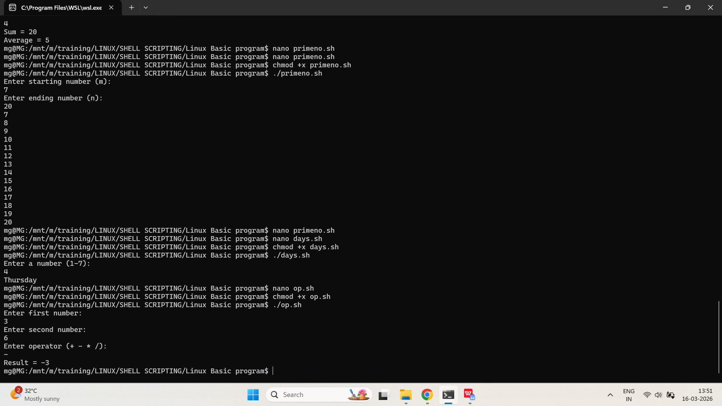

Traffic Light Simulation
Input can be red, yellow, or green.
Use a case statement to print:
Red → Stop
Yellow → Get Ready
Green → Go

PROGRAM:

#!/bin/bash

echo "Enter traffic light color (red/yellow/green):"
read color

case $color in
red)
echo "Stop"
;;

yellow)
echo "Get Ready"
;;

green)
echo "Go"
;;

*)
echo "Invalid input"
;;
esac

OUTPUT:

